

**2ND SEMESTER 2021/2022 ACADEMIC YEAR**

**MID SEMESTER EXAMINATION ANSWER BOOKLET**

THE FOLLOWING DETAILS MUST BE COMPLETED BY THE STUDENT

400

ADS19A00110Y

STUDENT’S ID NUMBER­­­­­­­­­­: _______________________________ LEVEL:__________

TE303

Wireless and Mobile Communication

COURSE COD**E: _________** COURSE TITLE: _________________________________

EBEN NORNORMEY

LECTURER’S NAME: (Refer to the Question Paper) ________________________________

**QUESTION NUMBER: (e.g. Q1) ___1___SUB-QUESTION (e.g. 1(a)) ___1A,B,C,D____**

1. Reason why the shape of a cellular cell is HEXAGONAL

It is hexagonal because if a circle were used, there might be an overlap between any two such neighboring circles or a gap between their coverage regions. Hexagonal is utilized to prevent this.

Mathematically Explanation of cluster size of cell that has the shift parameters **I = 2 & j = 1**;

Formula;

**N = i2 + i*j + j2**

**= 22 + 2*1 + 12**

**= 4 + 2 + 1**

**= 7**

Diagram of the reuse cells

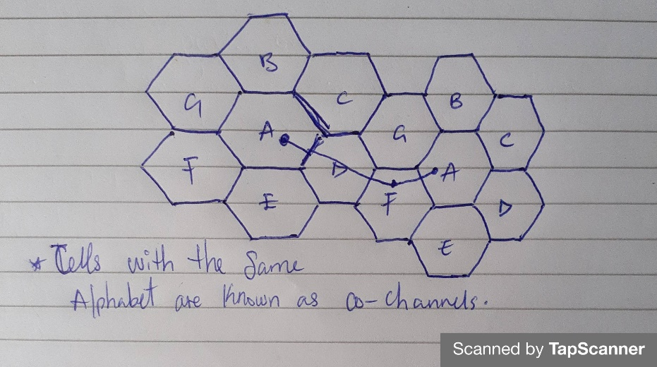

1. Cellular Concept and three factors of cellular concept in Mobile Telephony:

A cellular concept is a system-level theory that suggests replacing one large, high-power transmitter with many smaller, lower-power transmitters, each of which covers just a small section of the service area. By frequently reusing, it expands the capacity of the system.

There are many factors but only three will explained and they are;

**Cell Sectioning**: One Omni-directional antenna is switched out for three or six directional antennas (1200 Sectioning), depending on the application (60 Sectioning). Each cell has three or six sections. Each sector has a set of channels assigned to it and utilizes a directional antenna at the base station.

**Hand-off/Hand over**: It is a procedure wherein the mobile switching center (MSC) immediately changes the call to a new channel assigned to the next cell when a mobile phone moves from one cell to the next during a call. It is comparable to a first call request. It must to be effective, frequent, and unreachable by the user.

**Frequency**-**Reuse**: In order to provide service to a bigger number of mobile customers while having the same constrained frequency range, it is the procedure of allocating the same frequency to two or more non-adjacent cells. Only FDMA & TDMA networks (GSM) have this implementation; CDMA networks do not. The same channel set is used by cells with the same alphabet (clusters). In a cluster, no channel is reused.

1. Public Switched Telephone Network (PSTN);

It refers to the global telephone network that transmits analog voice data over copper lines. It comprises of a number of separate telephones that are permanently connected to a public exchange. Enables telephones, be it telephone lines, fiber optic cables, switched centers, cellular networks, satellites and cable systems to communicate with each other.

1. Importance of GPRS to 2G

* It effectively transfers user data packets using the packet radio technique.
* Compared to services that use circuit switching, this principle offers a billing system that is more user-friendly.
* The amount of sent data will determine how much the user is charged regardless of how long they are online.
* It made mobile phones capable of having small, portable internet connections for laptops.
* When a network signal is present, it provides wireless internet services regardless of location.
* The user can reach a faraway location and explore data using a laptop or mobile device while connected to the internet.
* The user can connect to the internet continuously via GPRS.

**QUESTION NUMBER: (e.g. Q2) ___3___SUB-QUESTION (e.g. 2(a)) _3A, B, C___**

1. Using the diagram below;

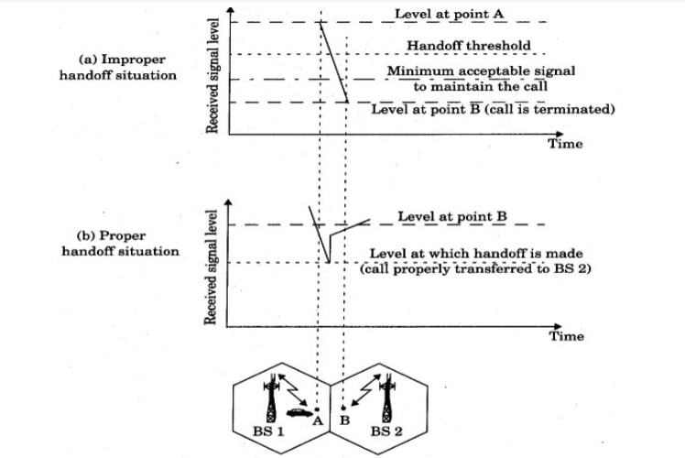

**Improper handoff**

The figure depicts the scenario in which a handoff is missed and the signal falls below the threshold necessary to maintain channel activity. When the MSC takes an inordinate amount of time to assign a handoff, the drop call is made.

**Proper handoff**

It is crucial to confirm that the recorded signal level decline is not the result of a temporary failure and that the mobile is genuinely moving away from the serving base station before selecting when to handoff.

1. **Calculating for Cluster size (N), Reuse ratio (Q), Reuse distance (D)**

When I =2, j = 2 and R = 60m

Using the formula;

= 22 + 2*2 + 22

= 4 + 4 + 4

**N = 12.**

**Q** = $\sqrt{3}*12$

= $\sqrt{3}6=6$

**D** = $60\sqrt{3*12}$

= $60\sqrt{3}6$

=60*6

= **360**

**Calculating for Cluster size (N), Reuse ratio (Q), Reuse distance (D)**

When I =3, j = 1 and R = 70m

Using the formula;

= 32 + 3*1 + 11

= 9 + 3 + 1

**N** = 13.

**Q** = $\sqrt{3}*13$

= $\sqrt{3}9=6.2$

D = 70 $\sqrt{3}*13$

= $70\sqrt{3}9$

= 70 * 6.2

**= 437.4**

1. All managed components in the switching system and the base station subsystem are connected to OMC (BSS). Fault management (maintenance duties), administration and business operation (subscription, billing, statistics, etc.), security management, network configuration, operation, and performance management are some of the OMC's functions.
2. The difference between BTS, BCS, SMSC and MSC

**BTS:** The Base Transceiver Station manages the radio communication protocols with the MS and houses the radio transceivers that establish a cell. A huge number of BTSs may be placed in a large urban area. The transceivers and antennas utilized in each network cell are represented by the BTS. Typically, a BTS is positioned at the cell's middle. The size of a cell is determined by its transmitting capacity. Based on the user density in the cell, each BTS contains 1 to 16 transceivers. BTSs function as single cells.

**BCS:** For one or more BTSs, the Base Station Controller oversees the radio resources. It manages frequency hopping, handovers, and radio channel setup. The BSC serves as the MSC's interface with the mobile device. The BSC also converts the standard 64 Kbps voice channel that is used by Public Switched Telephone Network (PSDN) or ISDN from the radio link's 13 Kbps voice channel. The BSC manages intercell handover as well. It manages the BSS and MS's power transmission in its region. The BSC's role is to divide up the required time slots between MSC and the BTS. It manages the radio resources like a switching device.

**SMSC:** An SMS message is sent from a device to the short message service center, which then relays it to the appropriate recipient. The SMSC will hold the information until either the device is available again or until the SMS expires if the recipient is unavailable (often denoting that the device is off or not receiving service).

**MSC:** The Mobile Services Switching Center is the main element of the Network Subsystem. The MSC manages mobile services like registration, authentication, position updates, handovers, and call routing to a roaming user in addition to transferring calls between mobile and other fixed or mobile network users. Additionally, it handles tasks like network interface, common channel signaling, and toll ticketing, among others. A distinctive ID is used to identify each MSC.

**QUESTION NUMBER: (e.g. Q2) ___5___SUB-QUESTION (e.g. 2(a)) _5A, B, C___**

1. S/I = 17db

Converting 17db to power

10log10 = db.

10log10 = 17

log10 = 17/10

= 1.7

S/I = 101.7

= **50.118**

I =3, j=2

Calculating of cluster size N

N = i2 + i*j + j2

= 32 + 3*2 + 22

= 19

Omni – directional characteristic = 6

Shift parameter = 19

Optimal value of the path lost exponent Y =?

Q = $\sqrt{3}N$

Finding Y =

n = path loss exponent = r/2

= 50.118 = ()n / 6

= ()n = 50.118 * 6

= ()n = 300.714

= ()n = 300.714

= ()n = 300.714

= (57) n/2 = 300.714

n/2 log1057 = log10300.714

n/2 * log57 = 17.55

log 300.714 = 24.78

n/2 * 17.55 = 24.78

17.55n / 17.55 = 24.78 / 17.55

**n = 2.823**

1. S
2. Components of 4G;

* **The User Equipment** which is essentially a mobile device and is designated by UMTS (3G) and GSM (2G). Any communication tool directly used by an end user. Any other device, like a laptop with a mobile broadband adaptor, may be used.
* **E-UTRAN** – The Evolved Base Station, or eNodeB, is the only part of the E-UTRAN (The Radio Access Network), which manages radio communications between cell phones and the EPC. Each eNodeB serves as a base station for one or more cells of mobile phones.
* **Evolved Packet Core**: This system allows speech and data to be delivered concurrently via a 4G long-term Evolution network.

1. The social challenges in mobile telephony that call for evolution of 5th generation cellular telephony is;

* High speed and high capacity was needed
* Large phone memory and dialing speed were required.
* Voice, streaming video, and internet were also required.
* More efficient and appealing.
* Video and audio clarity